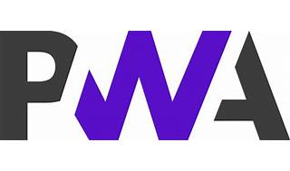



Explore

[A **Progressive Web App (PWA)** is an application built using web technologies that provides a user experience similar to that of a platform-specific app, combining the best features of traditional websites and native mobile apps1](https://developer.mozilla.org/en-US/docs/Web/Progressive_web_apps/Guides/What_is_a_progressive_web_app)[2](https://developer.mozilla.org/en-US/docs/Web/Progressive_web_apps)[3](https://www.techopedia.com/definition/33322/progressive-web-app-pwa).

Here are **five free resources** where you can learn more about PWAs:

1. [**Learn Progressive Web Apps**](https://web.dev/learn/pwa/): This comprehensive course covers every aspect of modern PWA development, from foundational concepts to advanced techniques[4](https://web.dev/learn/pwa/).
2. [**Free PWA Courses**](https://coursesity.com/free-tutorials-learn/pwa): A collection of free PWA tutorials from various online education platforms, including Udemy, Coursera, and YouTube[5](https://coursesity.com/free-tutorials-learn/pwa).
3. [**MDN Web Docs Tutorials**](https://developer.mozilla.org/en-US/docs/Web/Progressive_web_apps/Tutorials): MDN offers tutorials that walk you through creating PWAs, explaining different features and implementation steps[6](https://developer.mozilla.org/en-US/docs/Web/Progressive_web_apps/Tutorials).
4. [**Progressive Web Apps (PWA) — The Complete Guide**](https://medium.com/quick-code/top-tutorials-to-learn-progressive-web-app-pwa-57bdf06af328): This course teaches you how to build a PWA with features like device camera access and push notifications[7](https://medium.com/quick-code/top-tutorials-to-learn-progressive-web-app-pwa-57bdf06af328).
5. **Google’s PWA Training**: Google provides a series of interactive lessons and labs to help you master PWA development.

Happy learning! 🚀🌐